# Lab 4 - Router Configuration

|  |
| --- |
| * This is an individual assignment, and is worth 20 points. * You need to provide the answers using the accompanying outcome file. Change the file name following the naming convention suggested below. * Naming convention is as follows: homework, underscore, last name, first initial, and extension (e.g., Lab 1_ImG.docx). If you do not follow the convention, I will deduct 1. * The due date and time is Friday midnight. However, if you are in the lab today, you are supposed to finish it before you leave the lab. |

Task #1. Take a screenshot here.

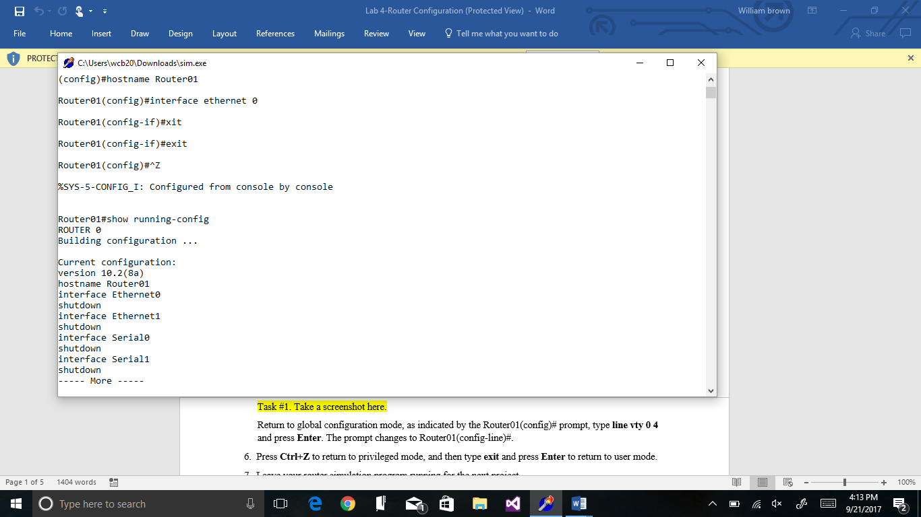

Task #2. Take a screenshot here. 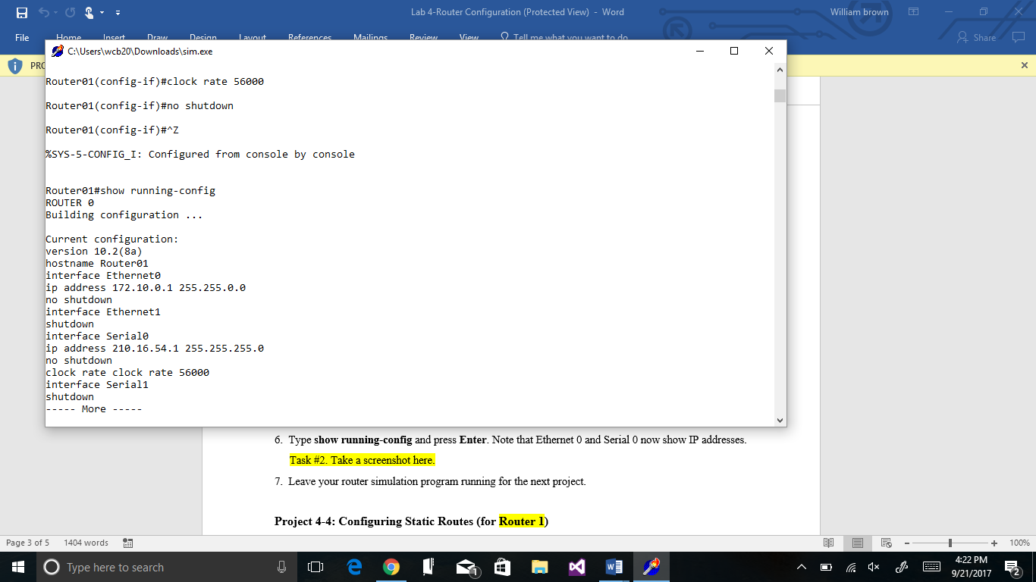

Task #3. Take a screenshot here.

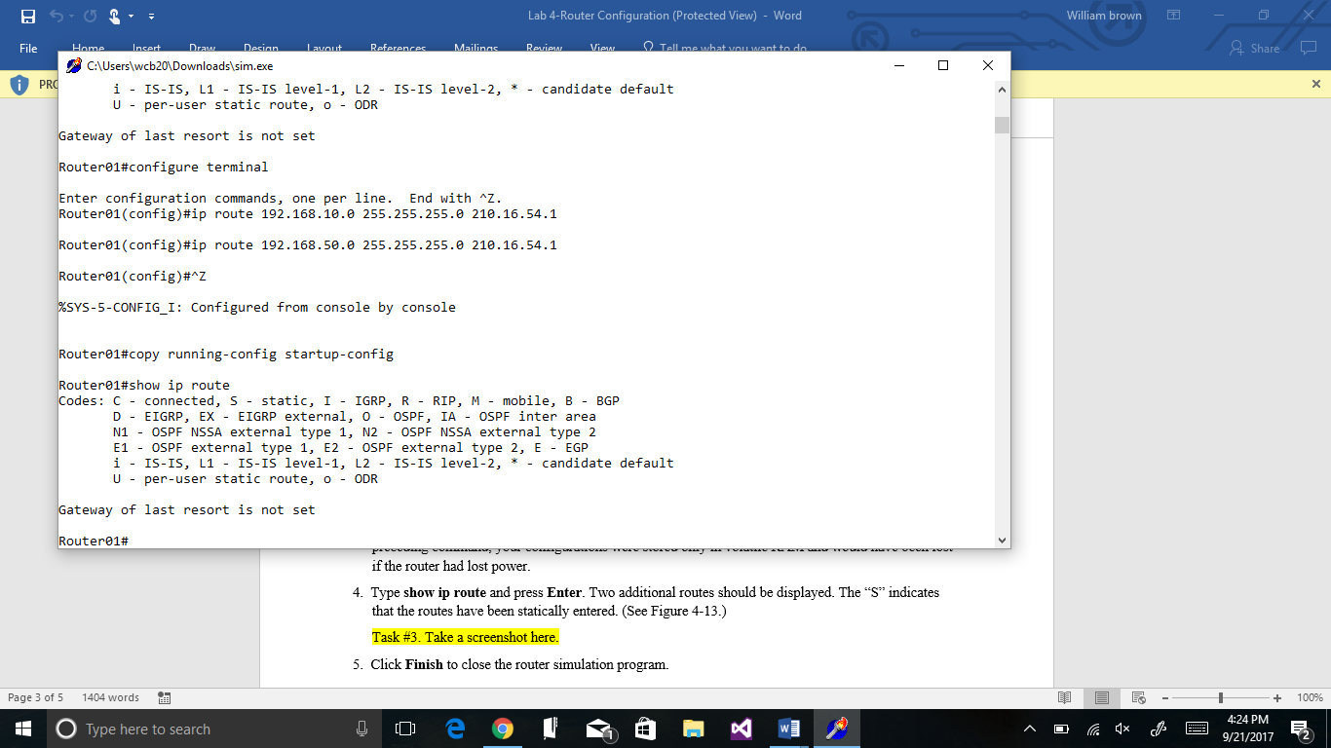

Task #4. Provide the routing table for Router 2.

|  |  |  |
| --- | --- | --- |
| Destination | Subnet Mask | Next hop |
| 172.10.0.0 | 255.255.0.0 | 210.16.54.2 |